

Programme Name: ________**BCS HONS**_______________________________________

Course Code: __**CSC 2330** _______

Course Name: ___**Software Project Management**_____ ______________________________

**Final Examination**

Date of Submission: ______**3/1/2020**_____________

**Submitted By: Submitted To:**

Student Name**: Dipesh Tha Shrestha** Faculty Name**:** **Satyam Paudel**

IUKL ID: **041902900028** Department**: LMS**

Semester**: Third Semester**

Intake**: September 2019**

1. Suppose your company is trying to decide whether it should buy special equipment to prepare some of its high-quality publications itself or lease the equipment from another company. Suppose leasing the equipment costs $240 per day. If you decide to purchase the equipment, the initial investment is $6800 and operations will cost $70 per day.
2. After how many days will lease cost equals to the purchase cost for the equipment?

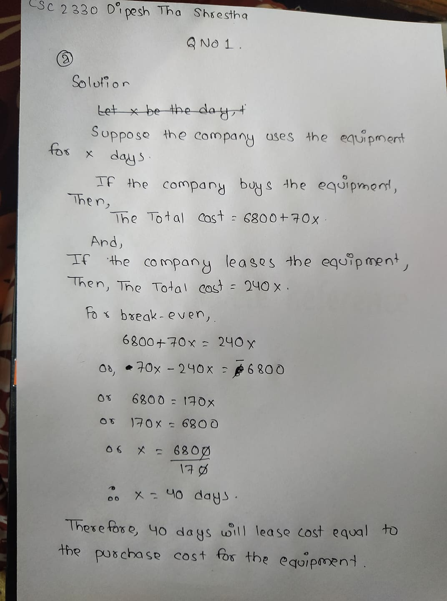

1. Assume your company would use this equipment for 30 days. Should your company buy the equipment or lease it? Give reasons.

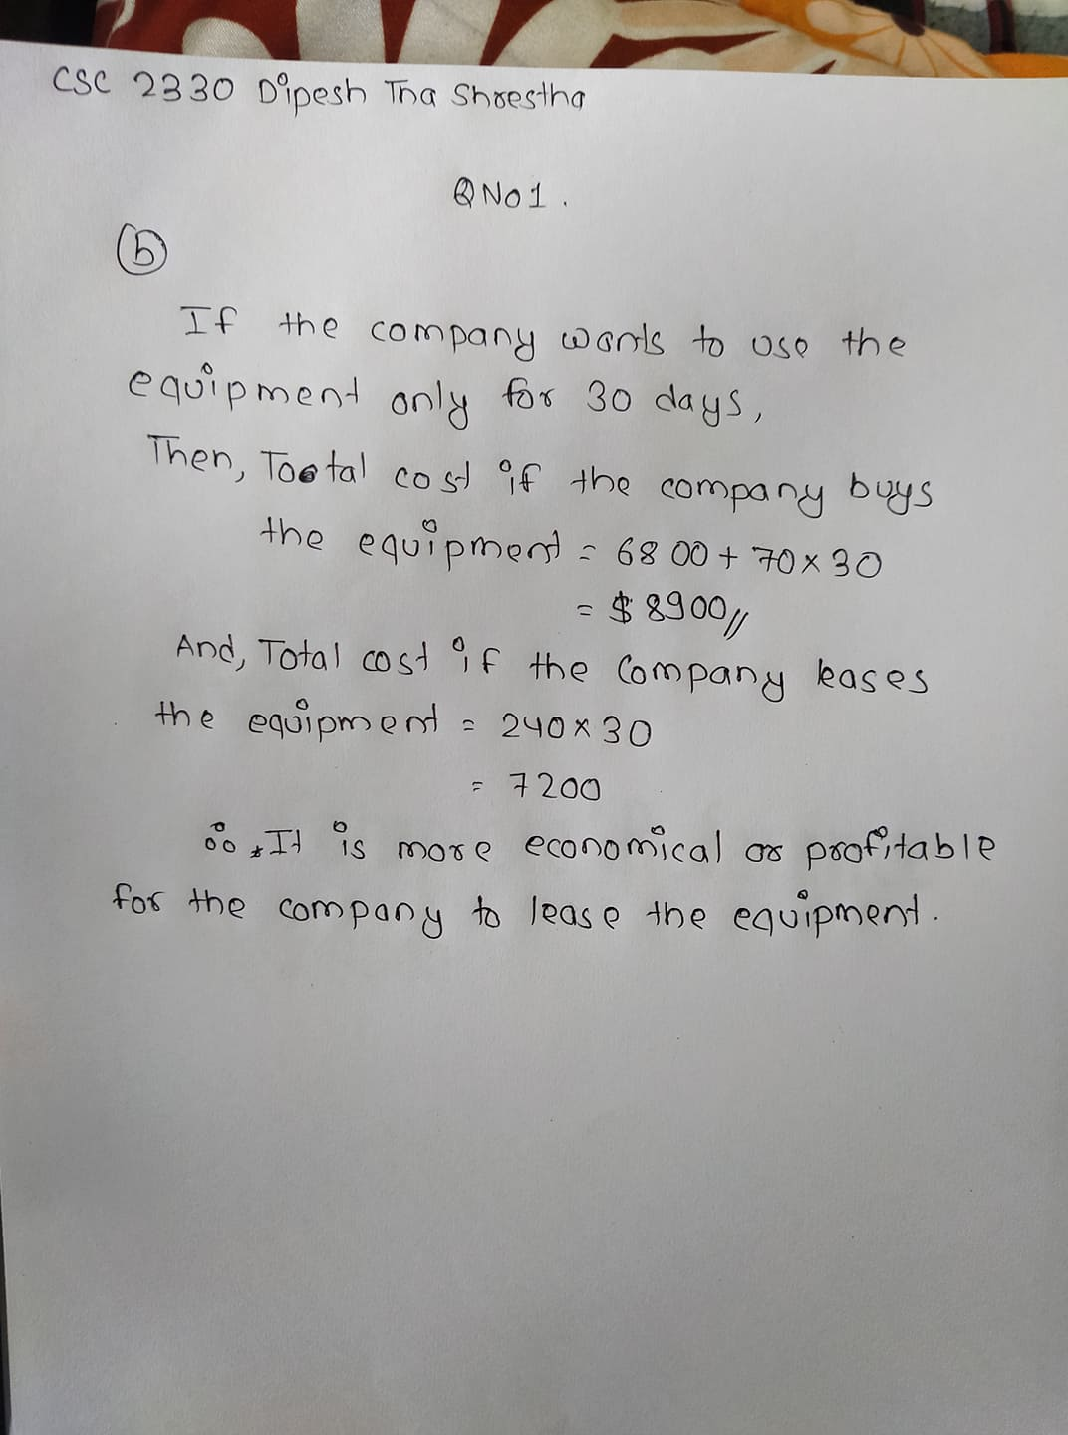

1. Perform a financial analysis of a project assuming that the projected costs and benefits for this project are spread over four years as follows: Estimated costs and benefits are given below.

Use a 10 percentage discount rate, round the discount factors to two decimal places.

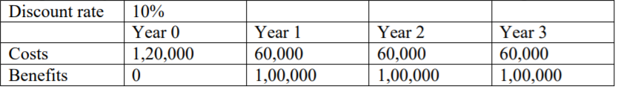

1. Create a financial template on the paper to calculate Discount Factor, Discounted Cost and Discounted Benefits for each year.

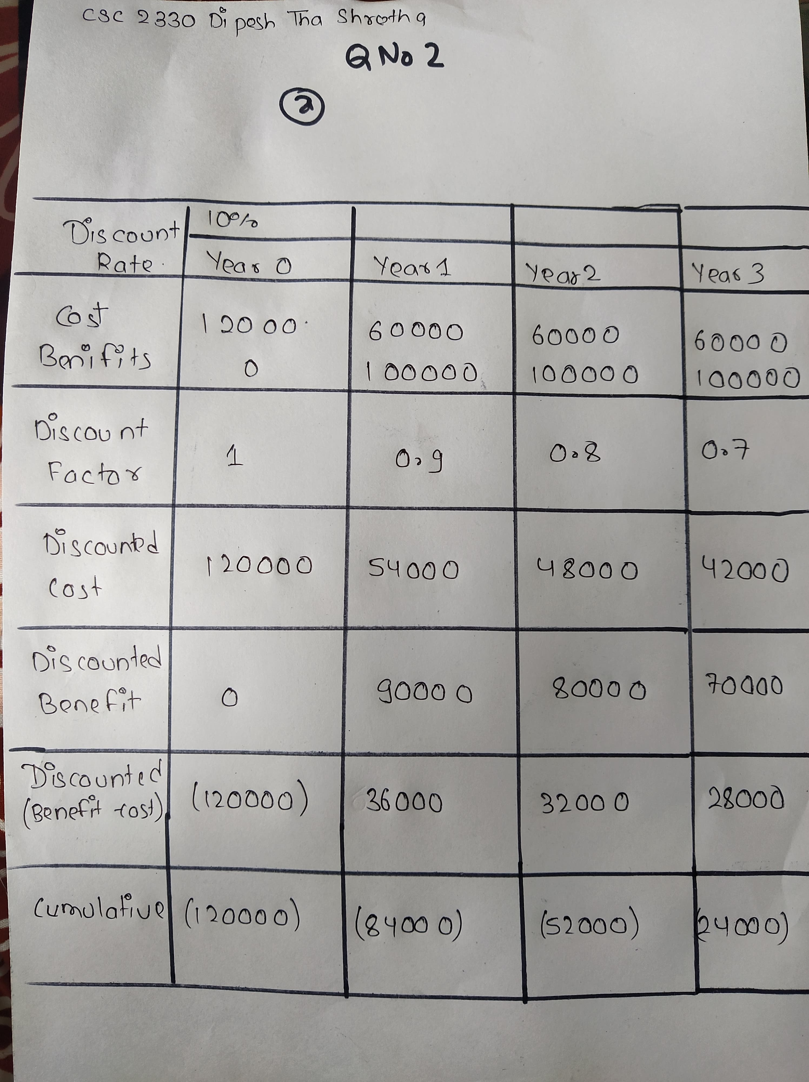

1. Calculate Net present Value

Answer: Net present value is: (1,20,000) + 36,000+32,000+28,000 = (24,000) (parenthesis denote value in negative. )

1. Calculate Return on Investment (ROI).

Answer: Return on Investment (roi) = 100%- (24000/300000 *100%)

= 100-8

= 92%

1. Calculate the year in which the payback occurs.

Answer: Payback does not occur in this scheme.

1. Suggest whether you would recommend investing in this project with the justification.

Answer: I would definitely not recommend to investing in this project because the return on investment is less than 100% and payback does not occur in this project.

1. Assume that you have completed three months of the project. The BAC was $200,000 for the six month project. You can also make the following assumptions:

PV= $120,000

EV= $100,000

AC= $90,000

1. Calculate Cost variance
2. Calculate Schedule variance for the project.
3. Calculate the Cost Performance Index.

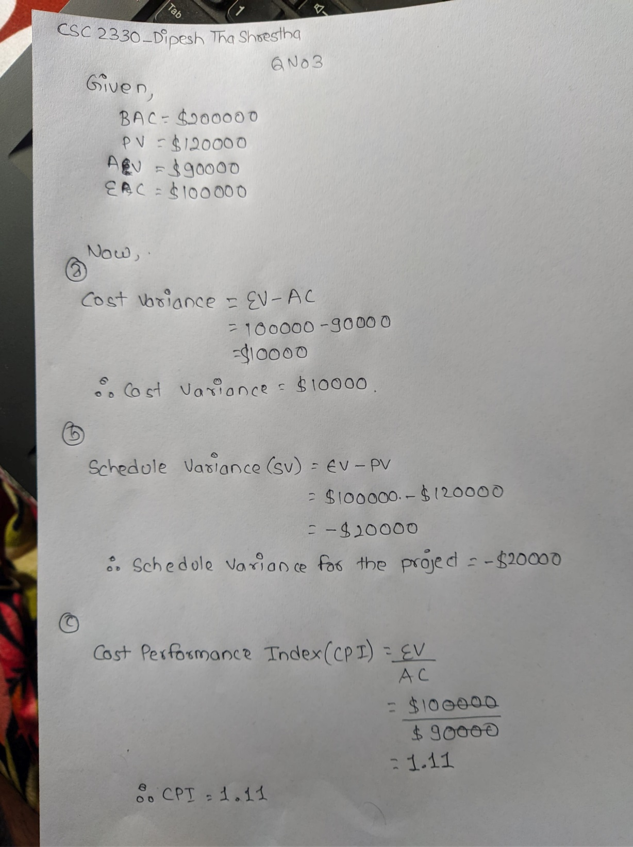

1. Calculate the Schedule Performance Index.
2. Calculate the Estimate at Completion
3. Estimate how long it will take to complete the project.

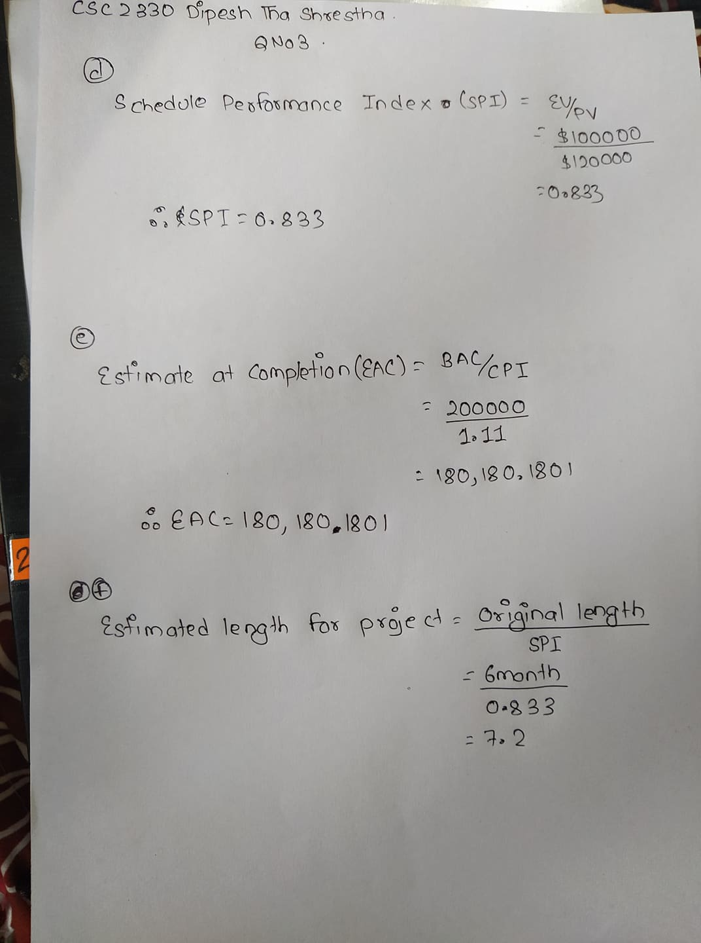

1. Is the project performing better or worse than planned? Is it Behind or ahead of schedule? Is it under budget or over budget?

Answer: The project now is over budget and behind the schedule. As you know, the project requires 7.2 month, which is longer tha planned and the project is performing worse than planned since the new estimate to complete it is more than planned.

1. Using the table below, answer the questions.

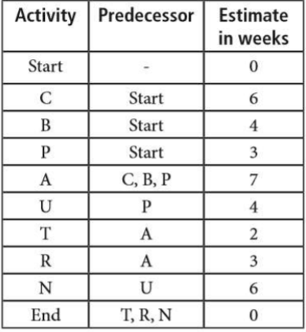

1. Draw the Network diagram for the above activities.

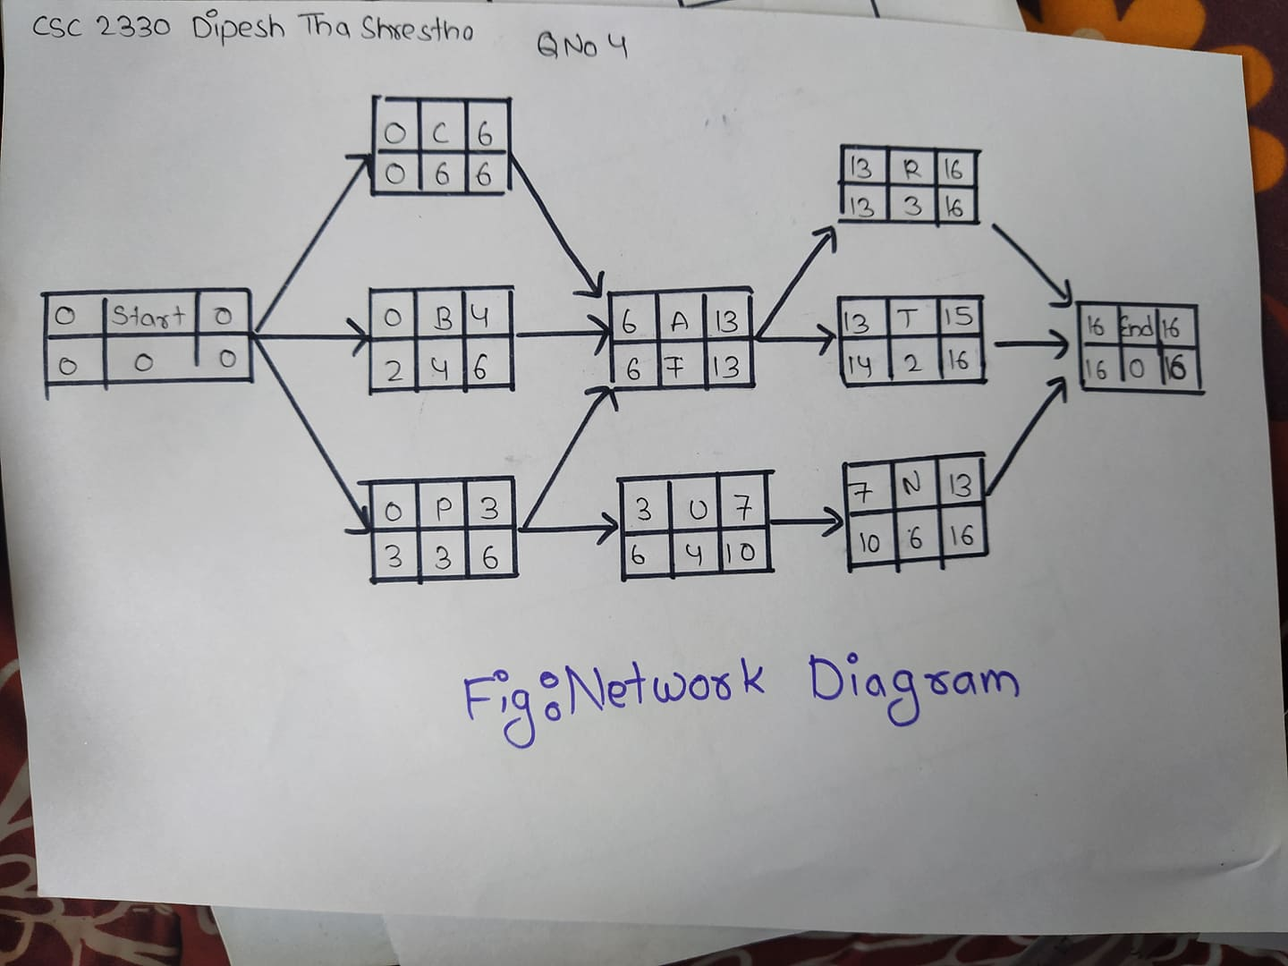

1. Identify the critical path

Answer: The critical path of this network diagram is :

START - C - A - R – END

1. Calculate the total duration for this project.

Answer: The total duration for this project is 16 weeks.

1. Draw the forward and backward pass for this network

Answer: Therefore, The Forward and Backward pass for this network is given in above diagram.

1. Calculate the float on activity U.

Answer: Float on activity U = LS - ES = 10 - 7 = 3weeks

1. Identify no of paths in the network.

Answer: The number of paths in this network are 7 paths.

**Thank you.**